# 一、Uboot源码vscode工程创建

# 二、顶层Makeile分析

AS = $(CROSS_COMPILE)as

AS = arm-linux-gnueabihf-as

2、变量值

ARCH = arm

CPU = armv7

BOARD = mx6ullevk

VENDOR = freescale

SOC = mx6

CPUDIR = arch/arm/cpu/armv7

BOARDDIR = freescale/mx6ullevk

# 三、编译处理过程

## make distclean

## make mx6ull_14x14_ddr512_emmc_defconfig

make xxx_defconfig的规则：

%config: scripts_basic outputmakefile FORCE

$(Q)$(MAKE) $(build)=scripts/kconfig $@

1、目标为scripts_basic

scripts_basic:

$(Q)$(MAKE) $(build)=scripts/basic

展开以后就是：

make -f ./scripts/Makefile.build obj= scripts/basic

build定义在scripts\Kbuild.include

build := -f $(srctree)/scripts/Makefile.build obj

build := -f ./scripts/Makefile.build obj

2、outputmakefile，

因为KBUILD_SRC，因此outputmakefile无效。

最终要执行的命令

make -f ./scripts/Makefile.build obj=scripts/basic

* Make -f ./scripts/Makefile.build obj=scripts/kconfig xxx_defconfig

第一条命令：

src = scripts/basic

kbuild-dir = ./scripts/basic

kbuild-file = ./scripts/basic/Makefile

include ./scripts/basic/Makefile

__build: $(if $(KBUILD_BUILTIN),$(builtin-target) $(lib-target) $(extra-y)) \

$(if $(KBUILD_MODULES),$(obj-m) $(modorder-target)) \

$(subdir-ym) $(always)

@:

__build: $(builtin-target) $(lib-target) $(extra-y) $(subdir-ym) $(always)

@:

scripts/basic/fixdep

__build: scripts/basic/fixdep

因此需要编译出scripts/basic/fixdep，对应的.c是scripts/basic/fixdep.c，

第二条命令：

Make -f ./scripts/Makefile.build obj=scripts/kconfig xxx_defconfig

src = scripts/kconfig

kbuild-dir = ./scripts/ kconfig

kbuild-file = ./scripts/ kconfig/Makefile

include ./scripts/kconfig/Makefile

%_defconfig: $(obj)/conf

$(Q)$< $(silent) --defconfig=arch/$(SRCARCH)/configs/$@ $(Kconfig)

xxx_defconfig: scripts/kconfig/conf

$(Q)$< $(silent) --defconfig=arch/$(SRCARCH)/configs/$@ $(Kconfig)

scripts/kconfig/conf --defconfig=arch/../configs/ xxx_defconfig Kconfig

### make V=1 -j12

默认目标

PHONY := _all

_all:

_all: all

all: $(ALL-y)

ALL-y += u-boot.srec u-boot.bin u-boot.sym System.map u-boot.cfg binary_size_check

u-boot.bin: u-boot-nodtb.bin FORCE

$(call if_changed,copy)

u-boot-nodtb.bin: u-boot FORCE

$(call if_changed,objcopy)

$(call DO_STATIC_RELA,$<,$@,$(CONFIG_SYS_TEXT_BASE))

$(BOARD_SIZE_CHECK)

u-boot: $(u-boot-init) $(u-boot-main) u-boot.lds FORCE

$(call if_changed,u-boot__)

u-boot-init := $(head-y)

u-boot-main := $(libs-y)

head-y= arch/arm/cpu/armv7/start.o

libs-y=保存源码的目录

libs-y += lib/ -》lib/built-in.o

libs-y保存大量的built-in.o

u-boot就是将start.o 和大量的built-in.o链接在一起。

假如

CONFIG_ONENAND_U_BOOT =y

ALL-$(CONFIG_ONENAND_U_BOOT)

ALL-y += u-boot-onenand.bin

# 四、链接

链接脚本为u-boot.lds，uboot链接首地址为0X87800000，

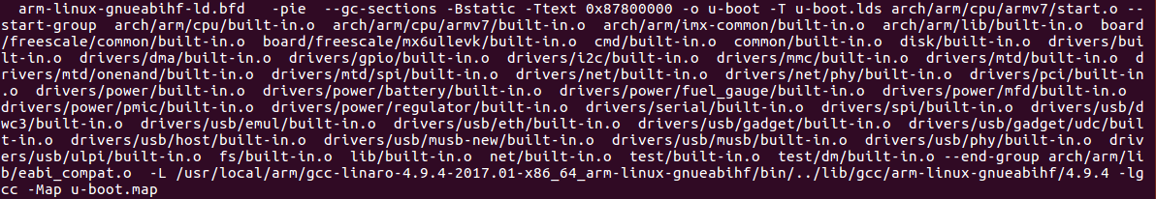

在mx6_common.h文件中设置CONFIG_SYS_TEXT_BASE=0X87800000